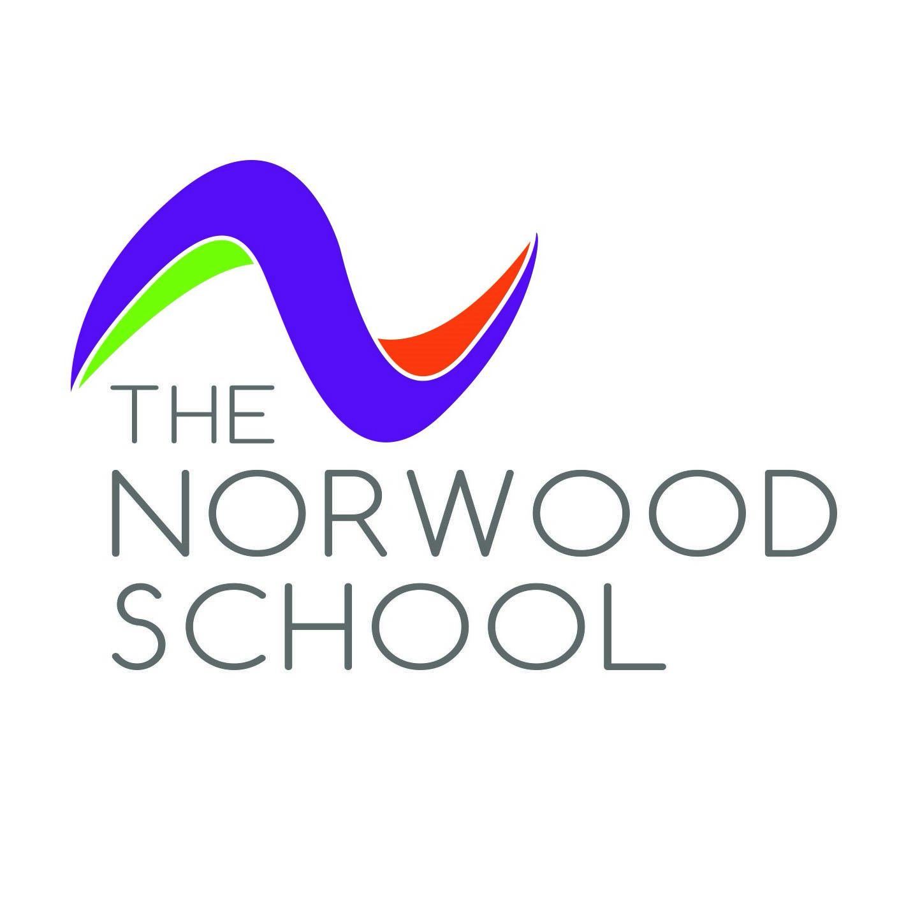

PHSE/RSHE POLICY
Learning for Life

The Norwood School

PHSE/RSHE POLICY
Learning for Life
Date: September 2024

Introduction
Today’s children and young people are growing up in an increasingly complex world and living their lives seamlessly on and offline. This presents many positive and exciting opportunities, but also challenges and risks. In this environment, children and young people need to know how to be safe and healthy, and how to manage their academic, personal and social lives in a positive way.

We are clear that parents and carers are the prime educators for children on many of these matters. Norwood School will complement and reinforce this role and we will build on what pupils learn at home as an important part of delivering a good education. We are passionate about delivering outstanding provision to support the personal development and pastoral needs of all of our pupils. We have carefully planned the Learning for Life curriculum according to the needs of the pupils and our community.

Our Learning for Life Curriculum supports the wider work of the school in helping to foster pupil wellbeing and develop resilience and character that we know are fundamental to pupils being happy, successful and productive members of society.

At Norwood we recognise that these subjects represent a huge opportunity to help our children and young people develop. The knowledge and attributes gained will support their own, and others’, wellbeing and attainment and help young people to become successful and happy adults who make a meaningful contribution to society.

We think that it is important that our pupils should be taught the facts and the law about sex, sexuality, sexual health and gender identity in an age-appropriate and inclusive way. All pupils should feel that the content is relevant to them and their developing sexuality. Sexual orientation and gender identity is explored at a timely point and in a clear, sensitive and respectful manner. When teaching about these topics, staff must be recognised that young people may be discovering or understanding their sexual orientation or gender identity. There will be an equal opportunity to explore the features of stable and healthy samesex relationships. This is integrated appropriately into the Learning for Life programme, rather than addressed separately or in only one lesson.

Aims of the Learning for Life Programme

The aim of the Learning for Life curriculum is to enable children to develop feelings of self-respect, self-esteem, self-confidence, sympathy and empathy. Developing these skills will enable them to make informed choices about their lives and relationships both now and in the future. Learning for Life is rooted in the context of our school community; working in partnership with families, we generate an atmosphere in which students can ask questions and discuss matters without embarrassment and receive answers at an age appropriate level. Pupils will also know where they can access additional support and guidance on related issues.

RSHE Learning for Life Core themes

- Relationships Education
- Relationships and Sex Education
- Health Education

The Relationships and Sex Education Learning for Life curriculum aims to form the fundamental building blocks and characteristics of positive relationships including:

- Families and people who care for me
- Respectful relationships
- Online relationships
- Being safe
- Intimate sexual relationships

These areas of learning are taught within the context of family life taking care to ensure that there is no stigmatisation of children based on their home circumstances. Pupils understand that families can include single parent families, LGBTQ+ parents, families headed by grandparents, adoptive parents, foster parents/carers amongst other structures.

The Health Education element of the Learning for Life curriculum aims to teach students about the importance of both physical health and mental wellbeing. This includes:

- Mental wellbeing
- Physical health and fitness
- Internet safety and harms
- Healthy eating
- Drugs, alcohol and tobacco
- Health and prevention
- Basic first aid
- Changing adolescent body

Many aspects of the RSHE curriculum will be delivered across the broader and PSHE curriculum these include:

- HEALTH AND WELLBEING
- RELATIONSHIPS
- LIVING IN THE WIDER WORLD

Our Learning for Life education addresses both pupils’ current experiences and preparation for their future. Our Programme of Study therefore provides a spiral curriculum that develops knowledge, skills and attributes, where prior learning is revisited, reinforced and extended year on year.

Teaching and Learning We know that effective teaching in these subjects will ensure that core knowledge is broken down into units of manageable size and communicated clearly to pupils, in a carefully sequenced way, within a planned programme or lessons. Teaching will include sufficient well-chosen opportunities and contexts for pupils to embed new knowledge so that it can be used confidently in real life situations.

The team of Learning for Life Leads (Celica Douglas (Asst Head) Caroline Quay ( Head of Dance) and Harry Isitt (Teacher of History) and will work closely with all staff colleagues across all year groups and related curriculum areas to ensure Relationships Education, RSE and Health Education programmes complement, and do not duplicate, content covered in national curriculum subjects such as citizenship, science, computing and PE. We recognise that it is important to check prior knowledge and build this into the planning process to ensure a smooth transition between primary and secondary.

Our Learning for Life programme will be taught through a range of teaching methods and interactive activities including teacher-student interactions, pair and group work, the use of audio, visuals, film, theatre in education presentations, hands-on demonstrations and exercises, debating and discussion. Resources are prepared carefully to ensure that they are age appropriate and deliver the curriculum effectively. Approaches will vary with the materials to be used and the objectives of the lessons but will generally be student centred, interactive and involve discussion and group work. Lessons will be differentiated to ensure that the needs of all students are met. Typically the content of the Learning for Life curriculum will be taught by tutors in pastoral teams although there are also wider cross curricular links both explicit and implicit. External agencies will also be used to bring additional expertise. The PHSE/RSHE curriculum is embedded within the school’s wider curriculum and often taught within the broader curriculum. To support teachers in their role, training on the delivery of PSHE/RSHE is included in our professional development calendar.

Assessment
We recognise that there are many reasons why it is important that learning in PSHE education is assessed, including:
- Pupils need opportunities to reflect on their learning and its implications for their lives.
- Teachers need to know that learning has taken place, be able to demonstrate progress and identify future learning needs.
- Assessment increases pupils’ motivation and improves learning, as their raised awareness of their progress illustrates the value of this learning.

Our assessment allows the leadership team, parents, governors and school inspectors to see the Learning for Life programme’s impact on pupils and whole school outcomes, such as Ofsted judgements on personal development, safeguarding, spiritual, moral, social and cultural (SMSC) development and the promotion of fundamental British values. Without relevant assessment, all we can do is describe our provision, not show its impact.

The DfE also states in the statutory guidance for Relationships, Sex and Health education that “schools should have the same high expectations of the quality of pupils’ work in these subjects as for other curriculum areas” — therefore assessment and learning is central to our Learning for Life provision.

Formative assessment and reflections will help staff and pupils identify their knowledge and understanding of PHSE/RSHE topics and themes. Staff teaching PHSE/RSHE will be available to meet parents at Parents evenings and an annual report will indicate achievement and engagement in themes and topics.

Equality and Diversity
Norwood School complies with relevant requirements of the Equality Act 2010. Under the provisions of the Equality Act, schools must not unlawfully discriminate against pupils because of their age, sex, race, disability, religion or belief, gender reassignment, pregnancy or maternity, marriage or civil partnership, or sexual orientation (collectively known as the protected characteristics) At Norwood, we will make reasonable adjustments to alleviate disadvantage and are mindful of the SEND Code of Practice when planning for these subjects. We are alive to issues such as everyday sexism, misogyny, homophobia and gender stereotypes and take positive action to build a culture where these are not tolerated, and any occurrences are identified and tackled. At Norwood School we have a good understanding of pupils’ faith backgrounds and are proud of the positive relationships between the school and local faith communities. The religious background of all our pupils will be taken into account when planning teaching, so that the topics that are included in the core content are appropriately handled. We will ensure we comply with the relevant provisions of the Equality Act 2010, under which religion or belief are amongst the protected characteristics. We recognise that all staff have an important role to play in modelling positive behaviours. Norwood School pastoral and behaviour policies support all pupils.

Pupils with special educational needs and disabilities (SEND)
Learning for Life at Norwood is accessible for all pupils. High quality teaching that is differentiated and personalised will be the starting point to ensure accessibility.
We are also mindful of the preparation for adulthood outcomes, as set out in the SEND code of practice, when teaching these subjects to those with SEND. Norwood School is aware that some pupils are more vulnerable to exploitation, bullying and other issues due to the nature of their SEND. We recognise that Relationships Education and RSE can also be particularly important subjects for some pupils; for example those with Social, Emotional and Mental Health needs or learning disabilities. Such factors have been taken into consideration in designing and teaching these subjects.

Lesbian, Gay, Bisexual and Transgender (LGBT)
In teaching the Learning for Life programme we will ensure that the needs of all pupils are appropriately met, and that all pupils understand the importance of equality and respect. Norwood will comply with the relevant provisions of the Equality Act 2010, under which sexual orientation and gender reassignment are amongst the protected characteristics. We will ensure that all of our teaching is sensitive and age appropriate in approach and content. We expect all pupils to have been taught LGBTQ+ content at a timely point as part of this area of the curriculum.

Working with parents/carers and the wider community
The role of parents in the development of their children’s understanding about relationships is vital. Parents are the first teachers of their children. They have the most significant influence in enabling their children to grow and mature and to form healthy relationships. We want to ensure that we build a good relationship with parents on these subjects over time – for example by inviting parents into school to discuss what will be taught, address any concerns and help support parents in managing conversations with their children on these issues. This can be an important opportunity to talk about how these subjects contribute to wider support in terms of pupil wellbeing and keeping children safe.

Our Approach

PSHE is taught in a rolling programme of timetabled weekly single lessons and has status and profile, is valued by teachers and young people and is delivered and monitored to the same standard and with the same rigour as other subjects. At Norwood all teachers, the senior leaders and governors will ensure that PSHE/RSE is able to achieve its full potential for students, including;

- Its role in supporting safeguarding, SMSC, behaviour and personal development.
- Its contribution to preventing bullying and other unhealthy/unsafe behaviours.
- Its role in promoting academic achievement

The annual schedule of lessons and topics is shared with all staff in advance of delivery. Heads of Year will raise the content of the next week's lesson during their weekly Wednesday Pastoral Team meetings. We encourage and support students to develop positive relationships and develop their sense of self-respect and self-worth. This is done by acknowledging the value of each individual student and reflecting an understanding of the families that make up the Norwood School community. Our approach to the Learning for Life curriculum compliments our behaviour blueprint which encompasses three important elements:

- Ready
- Respectful
- Safe

We expect students to demonstrate respect and sensitivity towards others through their understanding of diversity and difference. Our approach takes into account a student's level of knowledge and awareness of the issues being addressed. Modern life has created significant challenges for current generations of children and the Learning for Life curriculum acknowledges the important part that school can play in preparing children to navigate their world. Forming positive relationships is a vital part of this process including the relationships that we build as a school with students and their families. Pupils must also learn to take responsibility for their actions and understand the consequences of their choices both now and in the future. They are supported to understand how to live life happily, safely and successfully through an awareness of mental and physical well being. By preparing our children for their lives ahead, we are supporting students to reach their full potential.

Statutory Requirements The Relationships Education, Relationships and Sex Education and Health Education (England) Regulations 2019, made under sections 34 and 35 of the Children and Social Work Act 2017, make Relationships Education and Health Education compulsory for all students receiving primary education. The requirement on schools to protect against discrimination is laid out in the Equality Act 2010. No student can be withdrawn from the content of the Relationship Education and Health Education curricula. Providing a secure learning environment for PSHE (including RSE) A safe learning environment helps students share feelings, explore values and attitudes, express opinions and consider those of others without attracting negative feedback. The school and classroom provides a learning environment, which is caring, supportive, safe, respectful and tolerant, while encouraging self-awareness, self-esteem, confidence and a sense of independence and responsibility.

We work closely with staff and students to ensure that lessons are taught in a safe supportive environment, while helping to minimise inappropriate and unintended disclosures. A question or comment deemed as inappropriate for whole class discussion, will be acknowledged and attended to on an individual basis. Should behaviour or verbal contributions raise concern that a young person may be at risk, the school’s safeguarding procedures will be followed. Procedures will be followed in line with the school's Anti-Bullying Policy, in the event of bullying or harassment.

Curriculum
Where the Learning for Life curriculum can be given context within other subject areas the topics may be taught in conjunction with other materials. The underlying rationale of the Learning for Life curriculum is that the principles underpin all areas of the curriculum. Therefore opportunities to discuss issues such as relationships, friendships or healthy lifestyles may arise in any subject from English or Science, PE or Computing.

Teachers will explore potential challenges and coping strategies as children encounter them, in an age appropriate manner. The Learning for Life curriculum has also been designed to promote mental wellbeing and the development of personal attributes such as resilience, kindness and integrity.

The Norwood character strengths are referred to across assemblies, behaviour systems and within the daily routines of our school. Information about when topics will be shared with families on the school website. Timetabling may need to be adapted each year so the lessons may occur at different points of the year and include drop down days.

How and when is PHSE/RSHE delivered across the school?
The Learning for Life curriculum is delivered in a variety of ways at Norwood, in both specified weekly lessons, but as you would imagine, also through a variety of assemblies, talks, workshops, tutor times, immersion days and also in curriculum time. During tutor time each day at the start of the day - pastoral staff deliver the following:

Mail on Monday - a Head of Year’s overview of the week ahead, with key, relevant, age appropriate messages and content. Year groups also meet on a biweekly rotation with an in person assembly, with frequent guest speakers, visiting professionals etc
Together Tuesday - the whole school listens to a prerecorded assembly on one of a number of themes and topics that are pre planned across the year ahead. Topics will frequently tie in with national and global celebrations or awareness days. Activities will rotate between Assembly/LTA and LDD. Tutors use the Let’s Talk About and the Let’s Discuss Diversity presentations to facilitate meaningful group discussions about current affairs and topics that we feel deserve a platform that will inform, stimulate productive discussion and raise awareness of important issues and campaigns.
Wellbeing Wednesday - these sessions will cover a range of topics including mental and physical health awareness and independent study techniques, eg VESPA.
Thoughtful Thursday - Silent reading/revision/tutor one to one’s
Feel Good Fridays - A chance for tutor groups to celebrate the positive and reward those who get it right.

Working with External Agencies
External agencies often support the delivery of Learning for Life. The Lambeth ‘Selecting and Managing the Work of External Agencies’ guidance for schools is adhered to for safeguarding and quality assurance purposes. External agencies are required to follow the school's safeguarding procedures and teachers remain present in externally-facilitated lessons. Evaluations of external provision are utilised to inform future planning. We frequently work alongside long standing professional partners who are fully trained to deliver workshops, lessons and assemblies on specific aspects of our Learning for Life, for example; Brook Advisory Services, DAES (Drugs and Alcohol Education Services, Stonewall, MIND, Tender, We Rise, Mizzen Foundation, Access Aspiration, Debate Mate, Fashion Minority Alliance, London Enterprise Agency, Construction Youth Trust, Solomon Theatre Co, Cardboard Citizens, Loudmouth Productions, Discovery Programme, Mothers Against Knife Crime, My Bank. UNidosh, Arts Emergency, Mark Evison, Jack Petchey Speak Out Challenge, TFL Bus Days, Social Mobility Foundation and Speakers for Schools etc

Immersion Days and Weeks There are also opportunities throughout the year when the school community focuses on a theme or topic for the day or up to a whole week - for example Show Racism the Red Card Day, Breast Cancer Awareness Day, International Day Against Homophobia/Trans/Bi Phobia, Movember, Allyship Week, Power of Identity Week, Remembrance Day, Allyship Week, National Careers Week, Students for Sustainable Futures Week, Duke of Edinburgh Residentials and expeditions, LIFE (London Fire Brigade) Project, LGBTQ+ History Month, First Give, Global Entrepreneurship Week, African Child Trust Day, Red Nose Day, World Afro Day, Transition Weeks for Yr 11 and 13 and transition programme for Yr 6 into 7 to name but a few.

Roles and Responsibilities
Students
Students have been consulted in the formation of the Learning for Life curriculum. Students are expected to engage fully in Learning for Life and, when discussing issues related to PHSE/ RSHE, treat others with respect and sensitivity. We are proud that our students come from a variety of culturally diverse backgrounds and are entitled to learn in a safe and supportive environment. We are aware that some students can use terms associated with sexuality as a way to harass other students. This is unacceptable and will be dealt with as any other form of bullying through the school's behaviour policy. An understanding of human difference is an important aspect of education and will be dealt with in a sensitive manner.

Families are consulted on the Learning for Life provision to ensure that materials and resources are age appropriate and the curriculum meets the statutory requirements and the needs of students. Similarly wider discussions may occur at any time that relate to relationships and well being. Parents will be informed about the policy through communications and links on the school website. We work closely with parents to ensure that they are fully aware of what is being taught and provide additional resources and support through where appropriate, for example, translated materials and communications to EAL families. As part of our whole school approach to PHSE/RSHE, Parent Information sessions will be hosted and will be open to parents and carers from all Key Stages, for example, DAES Teenagers/Drugs/Alcohol Forum and families will be signposted to useful Websites like Parent Zone that offer advice on online safety.

Teachers & support staff Teachers, specialist support staff and visiting practitioners are responsible for delivering the Learning for Life curriculum set out in this policy and ensuring a safe and respectful environment. All Norwood staff are responsible for modelling positive attitudes to PHSE/RSHE and responding to the needs of individual students. Staff are expected to be familiar with the PHSE/RSHE policy and direct any concerns or queries to the Senior Member of staff for PSHE/RSHE.

Senior Leadership Team The delivery of Learning for Life through lessons, collapsed timetable days and assemblies is monitored by the SLT responsible for PHSE/RSHE, Celica Douglas Asst HEad and DSL. She will work with the three leads to monitor the effective delivery of the curriculum through learning walks, work samples, planning scrutinies and student voice. The SLT is responsible for ensuring that the PHSE/RSHE policy is reviewed and developed through an Learning for Life working group, consultation with families and student voice.

The Co Headteachers are responsible for ensuring that PHSE/RSE is taught consistently across the school, and for managing requests to withdraw students from Sex Education in collaboration with Head’s of Year.

Governors The governing body will approve the PHSE/RSE policy, and hold the Co Headteachers to account for its implementation. A named Governor will take responsibility for monitoring and implementation of the PHSE/RSHE programme.

Safeguarding We will ensure that all Learning for Life discussions take place in a safe environment with clear ground rules laid out for all students and staff so that sensitive issues and pupils' questions can be answered and addressed. Teachers should encourage all students to discuss their concerns with an appropriate adult. Teachers should make it clear to students the level of confidentiality that they can offer. Due to the guidelines in the Child Protection Policy, teachers cannot offer or guarantee absolute confidentiality: Teachers need to be aware that effective PHSE/RSE, which brings an understanding of what is, and what is not acceptable in relationships, can lead to disclosure of a child protection issue. Pupils need to be reassured that their best interests will be maintained. We understand that this could lead to child protection action. Teachers will consult with the school’s Designated Safeguarding Leads for advice on all child protection matters. Students will be able to raise questions anonymously

Withdrawing a child from Relationships and Sex Education at Norwood We understand that some parents feel uncertain, and in some cases uncomfortable, with the topics covered in RSE. It’s important that parents and families support their child at home by providing a safe place for them to talk about things they may be struggling to understand. We are committed to working with families. Families are invited to contact the school directly with any queries or concerns. The resources used for all year groups are also available on request
A parent can’t withdraw their child from any component that forms part of the Relationships Education element of RSHE, such as lessons that teach about families, friendships, general health, risky activities and how to stay safe online and offline. However, parents do have the right to withdraw their child from some or all of the sex education components within RSHE up to three terms before they turn 16 (the legal age of consent). At this point, your child can choose to receive sex education if they would like to, and the school should arrange for them to receive this teaching in one of those three terms. If a parent does NOT wish their child to participate in such a session, then they must contact their child’s head of year in writing to express your wishes. HOY will then inform the co headteachers of those students not accessing this particular aspect of the Learning for Life Curriculum.
For the sake of clarity, there is no right to withdraw students from any component of the national science curriculum (i.e. what older people were taught in biology), such as learning about sexual organs or reproduction.

Documents that inform the school’s RSHE policy include:
- Education Act (1996)
- Learning and Skills Act (2000)
- Education and Inspections Act (2006)
- Equality Act (2010),
- Supplementary Guidance SRE for the 21st century (2014)
- Keeping children safe in education – Statutory
- safeguarding guidance (2016)
- SEND code of practice: 0 to 25 years (statutory guidance)
- Preventing and Tackling Bullying (advice for schools, including advice on cyberbullying)
- Children and Social Work Act (2017)
- The Equality and Human Rights Commission Advice and Guidance
- Mental Health and Behaviour in Schools (advice for schools)
- Promoting Fundamental British Values as part of SMSC in schools (guidance for maintained schools on promoting basic important British values as part of pupils’ spiritual, moral, social and cultural (SMSC)
- National Citizen Service guidance for schools
- Sexual violence and sexual harassment between children in schools (advice for schools)
- Respectful School Communities: Self Review and Signposting Tool (a tool to support a whole school approach that promotes respect and discipline)
- Behaviour and Discipline in Schools (advice for schools, including advice for appropriate behaviour between pupils)

This policy will be reviewed Summer 2025

